AGENDA - Little Hoole Parish Council  Members of the Council are summoned to the Parish Council Meeting to be held on  Mon 13th Jan 2025 at 7:00pm  The Lounge, Old Mill Court Retirement Housing, Liverpool Old Road, Walmer Bridge, PR4 5QU  Paul Cafferkey, Clerk & Responsible Financial Officer | 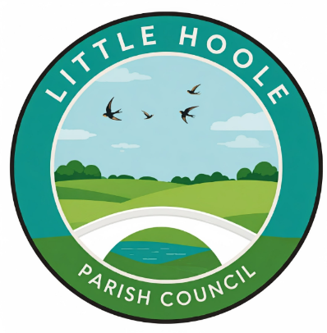

- Apologies for absence
- To agree the Minutes of the last Parish Council Meeting
- To receive declarations of interest
- Matters arising from the minutes of last meeting
  - Public Time: to invite and listen to issues raised by members of the public
  - Planning Applications:
- 07/2024/00854/HOH. 57A Liverpool Old Road Walmer Bridge PR5 5QA. Single Storey Rear Extension.
- 07/2024/00773/FUL. 67B Liverpool Old Road Walmer Bridge PR4 5QE. Alterations to shop front.
  - To approve the following transactions in the bank for Dec 2024:
Date | Payee | £ | Description
Current a/c
02-Dec-24 | Direct Debit (GOCARDLESS) | 36.96 | Monthly website fee
02-Dec-24 | B/P to: Festive Lights | 18.41 | Christmas Lights
03-Dec-24 | B/P to: McCluskey Window | 25.00 | Cleaning of Bus Shelters
03-Dec-24 | B/P to: Walmer Bridge VH | 50.00 | Room hire July & Sept
03-Dec-24 | B/P to: L T Dryden | 170.00 | Refund Cllr Dryden re pyt to A Watson re put up Christmas Lights, tidy Ego Roundabout, Community Garden
09-Dec-24 | B/P to: Peter Ashby | 119.15 | Refund to Cllr Ashby re purchase of Christmas Lights
16-Dec-24 | B/P to: Paul Cafferkey | 59.99 | Refund Clerk re annual MS365 subscription
16-Dec-24 | B/P to: L T Dryden | 146.09 | Refund Cllr Dryden re purchase of reflective tags for Little Hoole Primary School pupils
16-Dec-24 | B/P to: Paul Cafferkey | 147.65 | Clerk's pay for tax mth 09
16-Dec-24 | B/P to: Paul Cafferkey | 1.65 | Clerk's expenses for tax mth 09
31-Dec-24 | Service Charge | 6.00 | Monthly bank charge
Instant Access a/c
31-Dec-24 | Credit Interest | -131.09 | Income from Interest

  - Payments for approval - Clerk’s claim for Dec 2024
  - Payments approved by email or pre-approved and retrospectively noted – None.
  - To receive the Clerk’s Financial Statement report as at 30th Dec 2024
  - To agree transfer of monies from Parish Council current a/c to Parish Council Instant Access a/c.
  - Receipt of CIL (Community Infrastructure Levy) income - confirmation
  - Bus Service consultation – Update
  - Groundwork re play equipment, Dob Lane Recreation Park
  - To discuss flooding (culvert)
  - “In The Know” Newsletter from Lancashire Police
  - To discuss Lancashire Road Safety “Speed Concern” submission
  - PTA Grant – Update
  - To discuss adoption of .gov.uk email addresses
  - To confirm meeting dates for 2025
  - Information and Updates.
  - Correspondence – if applicable
  - To agree the date, time, and venue for the Feb 2025 meeting.
Members of the public are welcome to attend meetings to raise any relevant matters. Alternatively, if you cannot attend the meeting but wish to raise a matter or ask a question, this can be done on your behalf by contacting the Parish Clerk (Paul Cafferkey) via email at clerk@littlehooleparishcouncil.org.uk or mobile phone 07966267186.

Scan me to go the Little Hoole Parish Council Website, or visit https://www.littlehooleparishcouncil.org.uk/
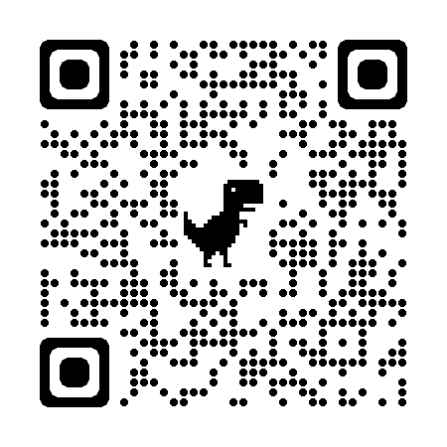
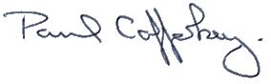
Prepared and approved by Paul Cafferkey, Clerk – Little Hoole Parish Council,
8th Jan 2025

